Room Capacity

Use the graph or table below to work out your normal teaching room capacity – complete the exercise on the reverse of this sheet.
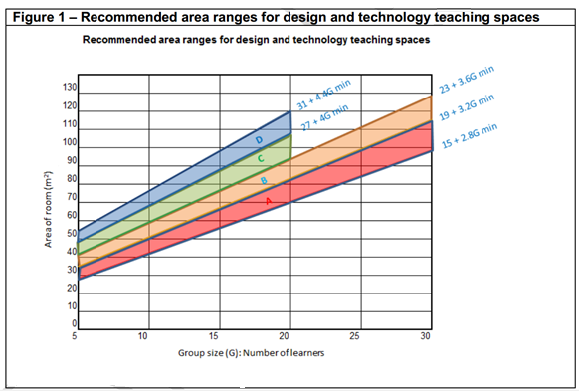
Figure 1 – Recommended area ranges for design and technology teaching spaces
Typical zones for various activities
- General teaching area Zone A
- Electronics & control systems Zone B
- Graphic activities Zone B
- Textiles activities Zone B
- Food activities Zone C
- Resistant material activities Zone D
- Engineering Zone D
Table 1 shows the area ranges for typical group sizes.
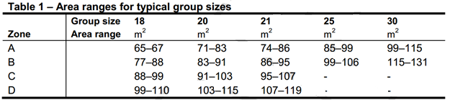

Building bulletin 81 (2004)

In the example under consideration, first calculate the floor area (So deduct the area covered by fixed benches) and move in along the corresponding horizontal line then drop vertically at the intersection to see the maximum group size that should be accommodated.

Floor area calculation

Type of activity

Calculated capacity

Note that none of the foregoing calculations actually take into account the floor area taken up by the furniture
Just out of interest, nearly 100 years ago ………
1918 Education Act and subsequent codes stated:
"The number of children on the registers of any class in Domestic Subjects, Handicraft, Gardening, and other practical subjects must not exceed 20…….”

